EXECUTIVE SUMMARY

Rongsai–Borjhora–Bajengdoba (RBB) Road do·a single lane pora intermediate lane do·a upgradation ka·se

Meghalaya Logistics and Connectivity Improvement Project (MLCIP)

Submitted
to


Meghalaya Infrastructure Development Finance Corporation (MIDFC) Ltd.
House No. L/A-56, Lower Nongrim Hills,Top Floor,
Meghalaya Basin Development Authority (MBDA) Building,
Shillong East Khasi Hills, Meghalaya-793003

ESIA Somaning (Summary)

Project Rang·chanchapa (Project Introduction)
Meghalaya Logistics and Connectivity Improvement Project (MLCIP) an·chingni miksongrangko dakchakanina kam ka·a, chong·motgipa nangchongmot ong·a:
a) chin·apgipa road corridor-rangni jakkalna dal·gipa bikrang aro growth center-rangona connection-ko namatna; b) grong-level aro district-level logistics infrastructure aro seva-rangko namatna;
c) select agriculture aro horticulture product-rangna marketona reach ong·e jakkalna, cost aro samai-ko komiatna; aro d) East Meghalaya-o climate-resilient transport aro logistics-ko chusok ong·e chalna institution-rangni capacity-ko bilangna.
Ka proposed road Meghalaya state formation do·a somoi na chonak, ar ROW (Right of Way) nangni ka existing drain doa pura limited a·se. Ka proposed Rongsai–Bajengdoba (RBB) project road ka total length 18.27 km a·se, Bajengdoba village do·a Chainage 0+000 a·se start ka·se ar Rongsai do·a Chainage 18+270 a·se end ka·se, ni project road khangni chonak.
Niyam aro kanun-rang baksa meligrik ong·ani bynta
ESIA-ara ia niyam aro kanun-rang baksa meligrik ong·a:
- World Bank Environmental aro Social Framework (ESF)
- Environmental aro Social Standards (ESS 1–10)
- India Government aro Meghalaya Government-rang environmental niyam
- Labour, forest, biodiversity aro pollution control-rang kanun

Project-rang kam-chalna samai-suchi
Nang·ni set criteria aro conditions-rang baksa, MPWD civil works contract-ko eligible contractor-na debak ong·a. Contractor-na quality materials-ko pora jakkalna, nearest authorized source aro approved manufacturer-na laga debak ong·a. Construction process-rangni somai, prescribed standard-rang meet gipa equipment-ara use debak ong·a. Contractor-na construction schedule-rang baksa required manpower-ko mobilize debak ong·a. Ka 18.27 km project road construction period 24 months doa plan ka·se.
Chong·ni pora environment-rang sthiti
Road corridor-rang soil sandy loam ong·a, well-drained aro moderately acidic ong·a, arangni region-rang high rainfall conditions-ina typical ong·a.
Water quality mostly fresh aro unpolluted ong·a, neutral pH-rang, sufficient dissolved oxygen-rang, low turbidity (monsoon-rang chadengsa except), aro low BOD/COD values ong·a. Industrial discharge nai, aro large-scale agricultural runoff-na water body-rang affect nai ong·a. Ning·a, ka groundwater quality drink ka·do·a suitable a·se, ar iron removal ka·do·a minimal treatment do·a safe ka·se.
Ambient noise environment mostly quiet to moderately noisy ong·a, rural area-rang characteristics-ina baksa. Baseline noise level-rang CPCB limit-rang residential aro rural area-rang somai, day aro night, most location-ona meligrik ong·a.
Project corridor-rang air quality good to moderate ong·a, rural Meghalaya-rang characteristic-ina, industrial activity kom ong·a. Ambient concentration PM₁₀, PM₂.₅, SO₂, NO₂, aro CO generally National Ambient Air Quality Standards (NAAQS)-na meligrik ong·a.
Environment aro community-rang upor project-rang potential effect
Ka proposed road corridor environment screening do·a, sensitive receptors ar community assets ka presence ka alignment do·a identify ka·se. Ni ka include educational institutions do·a schools ka Chainage 02+200, 03+200, 03+540 ar SSA School at CH 10+200. Healthcare facilities do·a Bajengdoba PHC (01+400) corridor do·a a·se. Religious ar community structures do·a churches ka 01+800 ar 02+914, Holy Family House at 02+557, Community Storage Shade at 00+188, Community Hall at 10+500, ar PWD Roads Transit Rest House at 02+400.

Other sensitive ar notable sites do·a Assistant Executive Engineer Office at 02+300, Post Office at 01+900, Hostel at 02+662, ar Paddy Fields at 01+765 a·se. Wildlife considerations do·a elephant crossing at 17+080 observe ka·se, ar community forest do·a stretches 17+100 to 17+500 do·a note ka·se.

Adverse impact-rang komiatna aro project implementation smooth ong·a baksa, appropriate mitigation measures propose gipa ong·a. Ni observation aro recommendation-rang summary table-ona dekha gipa ong·a.

Table: Observation-rang aro Corresponding Recommendation-rang
Chainage | EIS Observation | Proposed / Mitigation Measure
0+00 | Traffic congested conditions | T-junction improvement ka·se proposed
0+300 | Submergence during monsoon | New Bridge ka·se proposed
0+600 | Water logging | Box Culvert / level raise about 300 mm ka·do·a proposed
1+300 | Submergence during Monsoon season | Road level raise by 250 mm ka·do·a proposed
1+350 to 1+600 | Submergence during Monsoon season | Drain cum Footpath (LHS) ka·do·a proposed
2+150 | School | Speed restriction signs school do·a before ar after (Both sides of school) ka·se proposed
2+700 | Minor settlement along curve | Curve correction ka·do·a proposed to minimize impact
2+950 | Sharp curve | Speed restriction signs due to sharp curve ka·se proposed, accident avoid ka·se
8+600 | Soil erosion in river (LHS) | Toe wall / Protection works ka·do·a proposed due to soil erosion (LHS)
9+100 | Drain / Nalla 250 mm submergence during heavy rainfall | Appropriate drainage management ar erosion control works ka·do·a proposed
9+200 | Riverbank erosion observed | River training works ka·do·a proposed for erosion in bridge foundation
9+950 | Riverbank erosion observed | Protection works at riverbank (RHS) ka·do·a proposed
11+780 | Damaged culvert | Culvert failure, new culvert ka·do·a proposed
17+100 to 17+400 | Community land with vegetation ar 2 elephant passes | Elephant passes ar community land with vegetation ka·se located; speed calming measures ar warning signs ka·do·a proposed (no widening; work within existing paved road)

Community aro social-rang pora dekha gipa observation-rang

Ka social screening do·a findings ni table do·a present ka·se.
Table: Social Screening Findings
New CH No. | LHS / RHS | Structure / Details
02+200 | LHS at 20 m distance from centre line | School
00+188 | LHS at 24 m distance from centre line | Community Storage Shade
01+400 | RHS at 50 m distance | Bajengdoba PHC
01+800 | RHS at 50 m distance | Bajengdoba Baptist Church
01+900 | RHS at 17 m distance | Post Office
03+200 | RHS at 20 m distance | School
02+300 | RBB | Assistant Executive Engineer Office
02+400 | LHS at 50 m from centre line | PWD Roads Transit Rest House
02+557 | LHS at 20 m from centre line | Holy Family House
02+662 | RHS at 30 m from centre line | Hostel
02+914 | LHS at 30 m distance from centre line | Church
10+500 | RHS at 30 m distance from centre line | Community Hall
03+540 | RHS at 30 m distance from centre line | School
01+765 | RHS | Paddy Field
10+200 | LHS | SSA School
17+080 | LHS | Elephant Passing
17+100 to 17+500 | _ | Community Forest
FPIC-3 Suggestions by Community – Rongsai–Borjhora–Bajengdoba (RBB) Road
Date: 25-09-2025
Venue: Bajengdoba Multifacility Centre, Bajengdoba

Sr. No | Particulars / Village Name / Locality / Chainage | Suggestion / Query | Remarks | Compliance / Proposal in DPR
1 | Ch-0+000 to 0+300 | Community ka·se drain cum footpath, bus stop ar junction improvement starting point do·a demand ka·se | Both sides of the road | Km 0+000 to Km 0+250 foot path cum drain provide ka·se; Km 0+000 major junction improvement consider ka·se
2 | Ch-1+665 to 1+880 | Community ka·se toe wall demand ka·se | RHS | Km 1+640 to Km 1+820 toe wall propose ka·se as per design
3 | Ch-1+500 | Community ka·se toe wall demand ka·se, building protect ka·do·a approx 15 m length | RHS | Km 1+440 to Km 1+480 toe wall propose ka·se (LHS)
4 | Ch-2+000 | Culvert pora ka·do·a toe wall needed, soil erosion reduce ka·do·a | LHS | Km 1+980 to Km 2+120 toe wall propose ka·se (LHS)
5 | Ch-1+600 to 1+622 | Plant area protect ka·do·a toe wall needed | _ | Same as Sr. No. 2
6 | Ch-1+640 to 1+860 | Community ka·se toe wall demand ka·se | Both sides of the road | Same as Sr. No. 2
7 | Ch-1+980 to 2+060 | Community ka·se toe wall demand ka·se | Both sides of the road | Same as Sr. No. 4
8 | Ch-3+900 | Community ka·se PCC walls 1.5 m height ar 40 m length demand ka·se | LHS | Km 3+940 to Km 4+020 toe wall propose ka·se (RHS)
9 | Ch-5+370 to 5+400 | Community ka·se breast wall demand ka·se | LHS | Km 5+340 to Km 5+400 retaining wall propose ka·se
10 | Ch-6+200 | Alignment shift slightly left side ka·se | LHS | Shifted ka·se
11 | Ch-9+020 to 9+140 | Community ka·se toe wall demand ka·se | LHS | Km 9+000 to Km 9+080 toe wall propose ka·se (LHS)
12 | Ch-12+480 to 12+550 | Community ka·se toe wall / retaining wall demand ka·se | RHS | Km 12+480 to Km 12+560 toe wall propose ka·se (RHS)

GRM-rang process aro steps-rang diagrammatic representation
Nangni flowchart-rang show gipa ong·a two-tier grievance redressal mechanism, responsibilities aro resolution-rang timelines-rang baksa debak.
Project site-ona grievance redressal-rang baksa debak level | Responsibility: VECs & Headman  Timeline: Resolution within 15 days  If unresolved → Escalate to PMU (Tier II)
State level-ona, PMU-rang grievance redressal-rang baksa debak level | Responsibility: Secretary Planning, Chief Engineer,  Project Director, Social Expert  Timeline: Resolution within 15 days

Grievance Redressal Mechanism-rang process, responsibilities aro resolution-rang steps-rang baksa debak.
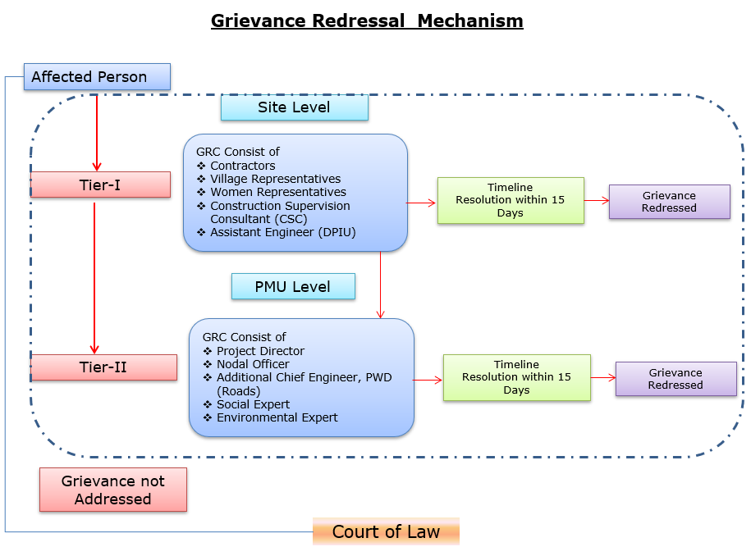
Grievances submit debak baksa contact information-rang baksa debak.
Baksa debak pora detail nai explanation | Baksa debak pora contact information, phone number, email, nai address
Company: | PWD, Meghalaya
To: | Chief Engineer-cum-Nodal officer
Address: | HV9P+GFJ, Lachumiere, Shillong, Meghalaya 793001
E-mail: | esmlcip@gmail.com
Website: | http://megpwd.gov.in/contacts.html
Telephone: | Tel: 0364-3572466
Fax: | -

Project-rang governance aro overall institutional structure-rang baksa debak.
Ka kam-rangkam ka dakgipa donggipa jylla Government of Meghalaya (GoM)-ni donggipa institutional architecture baksa meligrikgen, aro Sixth Schedule-ni niyam rangsani, janggi jatni hokrang (tribal autonomy)-ko dakchakgen.
MIDFC, je project-ni sabsi kamrangko dakchakgipa aro taka-paisani bynta nanggipa ong∙a, ua project-ni holder aro lead implementing agency ong∙gen.
MPWD-de civil works (rasta, bridge aro ropeway)-rangko dakchakgen, aro Department of Agriculture (DoA) aro MBMA-rangde agrologistics aro community components-rangko kam ka∙gen.
MIDFC-PMU-ni rangko project management aro coordination-rangko dakchakgen, World Bank-ni procedure-ko experience napha officers-ni through.
PMC, je team-ni expert aro consultant-rangni Team Leader-ni ong∙a dakchakgen, project activities-rangko technical support-ka∙gen, je implementing agencies-ni skill set-ni napha dang∙a.
CSC-ni construction supervision-ka∙gen.
PMC/CSC aro information collect aro document-ka∙gen-rangni aid ka∙gen.
Project implementation structure-ko figure-ni dang∙a dakchak:
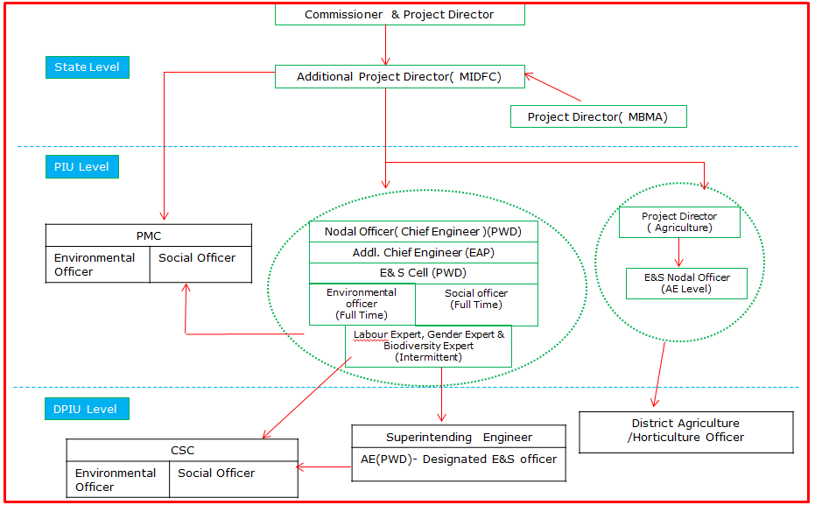
Figure: Project Kam-rangkam Organogram
Khutcha
ESIA-ni phayrang dakchakni phangni ni nangni gital:
• Proposed project-ni rasta-ni traffic flow-ni dakchakni aro motor vehicle aro pedestrian-ni safe aro smooth mobility-ka∙gen. Proposed road improvement-ni travel time-ni farthest section-ni rasta-ni dang∙a market-ni gi hour-ni 1 hako 30 minutes-ni mel∙a dakchak. Project-ni importance-ni trade aro commercial activity (public transport-ko include) East Garo Hills aro North Garo Hills-ni district-ni encouragement-ka∙gen.
• Environmental aro social impact assessment-ni World Bank ESF aro National & State regulations-ni meligrikgen. Pre-construction, construction aro operation phases-ni dang∙a potential impacts-ni dakchakni gital.
• Proposed project alignment-ni Wildlife Sanctuary/National Park/Biosphere Reserve/Tiger Reserve-ni dang∙a pasal-ni dakchak∙a.
• Project site-ni 0.5 km-ni dang∙a ASI Protected monuments-ni dakchak∙a.
• Approximately 20 trees existing Right of Way (RoW)-ni dang∙a road-ni sides-ni dakchakni. Tree felling-ni ecological impact-ka∙gen mitigation-ni, compensatory afforestation-ni applicable environmental regulations aro guidelines-ni meligrikgen dakchak∙a.
• Project road-ni construction activities-rangko environmental aro social impacts-ni dang∙a dakchakni; culturally important sites-ni proximity-ni (community center, church, school etc.) aro Project-Affected Persons (PAPs)-ni access-related issues-ni potential effect-ni dakchakni.
• Stakeholder Consultations-ni conducted dakchakni, proposed project-ni perception-ni assess-ka∙gen. Consultations-ni outcome-ni dakchakni, people-ni project-ni support-ka∙gen, karon road conditions aro connectivity-ni improve-ka∙gen. Tangni road safety measures; road furniture’s (streetlights, signage, speed breaker etc.) aro loss-of-assets-ni proper compensation-ni require-ni raised-ka∙gen.
• Occupational health aro safety measures-ni workers aro local community-ni ensure-ka∙gen, comprehensive Labour Management Plan (LMP)-ni prepare aro implement-ni through, World Bank Environmental and Social Standard ESS2 on Labor and Working Conditions-ni meligrikgen.
• Mitigation measures-ni environmental aro social monitoring-ni program-rangko construction aro operation phases-ni dakchakni assure-ka∙gen; implementation-ni confirm-ka∙gen aro environmental aro social conditions-ni stipulated or protected-ni check-ka∙gen. Observation on-site aro off-site, document check, workers aro beneficiaries-ni interview aro remedial action-ni requirement-ni contractor-ni MPWD-ni report-ka∙gen.
• ESMP-ni bidding document-ni include-ka∙gen, contractual clauses-ni project construction aro operation (maintenance period)-ni environment aro social impact safeguard-ni ensure-ka∙gen.
• Project-level aro construction stage-level Grievance Redress Mechanism (GRM)-ni form-ka∙gen, affected parties-ni feedback, suggestions aro complaints receive aro address-ka∙gen, construction aro operation stage-ni.
• Prepared ESMP-ni Contractor aro MPWD-ni assist-ka∙gen Environmental aro Social impacts mitigate-ka∙gen aro proposed project-ni environmentally sound execution-ni guide-ka∙gen.

Capacity building and training

Environmental aro Social Management Plan (ESMP)-ni implementation aro monitoring-ni capability-ni improve-ka∙gen, structured training programs-ni contractor aro project personnel-ni gi sabsi conduct-ka∙gen dakchakni recommend-ka∙gen.

Training-ni regulatory requirements-ni compliance ensure-ka∙gen, awareness improve-ka∙gen aro environmental aro social (E&S) risks-ni manage-ka∙gen competence build-ka∙gen.

On-Boarding Phase
a. Induction Training
• Sabsi personnel-ni work start-ka∙gen ni mandatory.
• Contractor-ni Environmental aro Social Management Plan (C-ESMP), relevant national aro international Environmental, Social, Health aro Safety (ESHS) regulations aro good practices-ni cover-ka∙gen.

b. Specialized Training

• Personnel-ni specific roles-ni (e.g., environmental officer, safety officer, waste management supervisor) assigned-ka∙gen tailored training.
• Mobilization stage-ni deliver-ka∙gen, assigned responsibilities-ni readiness ensure-ka∙gen.

Implementation Phase
- Ongoing Toolbox Talks:
Daily aro weekly conduct-ka∙gen, evolving risks address-ka∙gen, safety practices reinforce-ka∙gen aro workers-ni continuous awareness maintain-ka∙gen.
- Supplemental Training:
Incident-hako pare or new risks identify-hako pare provide-ka∙gen. Recurrence prevent-ka∙gen aro workforce-ni new safety/environmental requirements-ni updated rakha∙gen.
- Routine Quarterly Training:
Contractor-ni every three months organize-ka∙gen:
o E&S compliance status aro progress review-ka∙gen.
o Previous quarter-ni lessons learned share-ka∙gen.
o Identified gaps aro challenges address-ka∙gen action plans develop-ka∙gen.
o Sub-project E&S objectives-ni alignment ensure-ka∙gen aro continuous improvement promote-ka∙gen.

Outcomes of the stakeholders

Ampati–Purakhasia Road do·a FPIC process ni ka·se ka·be, community engagement strengthen ka·se ar final consent ka·se doh.
FPIC-I do·a, community ka·se roadside infrastructure pora concerns raise ka·se, jingni ka·se drains, footpaths, waiting sheds, bus stops ar zebra crossings schools ar junction pora, students ka·se safety, cycle parking areas, ar schools ar churches protect ka·do·a boundary walls. Flood-prone stretches ar major habitations approach roads pora concerns ka·se highlight ka·se. Project team FPIC process introduce ka·se, participants ka·se project objectives pora sensitization ka·se, ar community inputs planning ar design pora integrate ka·se assurance ka·se.
FPIC-II do·a, stakeholders project details, DPR presentation, ESIA findings, ar Grievance Redress Mechanism (GRM) pora deliberation ka·se. Women ar youth groups parallel sessions pora participate ka·se, specific perspectives capture ka·do·a. Community inclusive planning ar environmental safeguards emphasize ka·se, ar project team design ar safeguard measures pora concerns address ka·se commitment ka·se.
FPIC-III do·a, detailed designs, mitigation measures ar ESIA findings disclosure pora, community ka·se consent reconfirm ka·se ar previous commitments validate ka·se. Additional requests ka·se include safety measures, infrastructure ar community amenities. Project team ka·se incorporate ka·se confirmation ka·se ar objections ka·se record ka·se nai.

Resettlement Action Plan (RAP)

Resettlement Policy Framework (RPF)-ni gi meligrik, project-ni social impacts avoid aro minimize-ka∙gen measures adopt-ka∙gen, careful design aro existing RoW-ni use-ka∙gen.
Continuous consultations conduct-ka∙gen aro functional GRM-ni ensure-ka∙gen, concerns-ni timely resolve-ka∙gen. Sabsi entitlements RPF-ni meligrik provide-ka∙gen.
Road section-ni identified impacts-ko basis-ni, detailed site-specific Resettlement Action Plan (RAP) prepare-ka∙gen, ha·ni final entitlements, mitigation measures, implementation arrangements aro monitoring framework outline-ka∙gen, aro civil works start-hako pare implement-ka∙gen.

